R. W. Tonning, County Arborist 404.371.2685 (o) rwtonning@dekalbcountyga.gov | Clark Harrison Building  330 W. Ponce de Leon Ave  Decatur, GA 30030
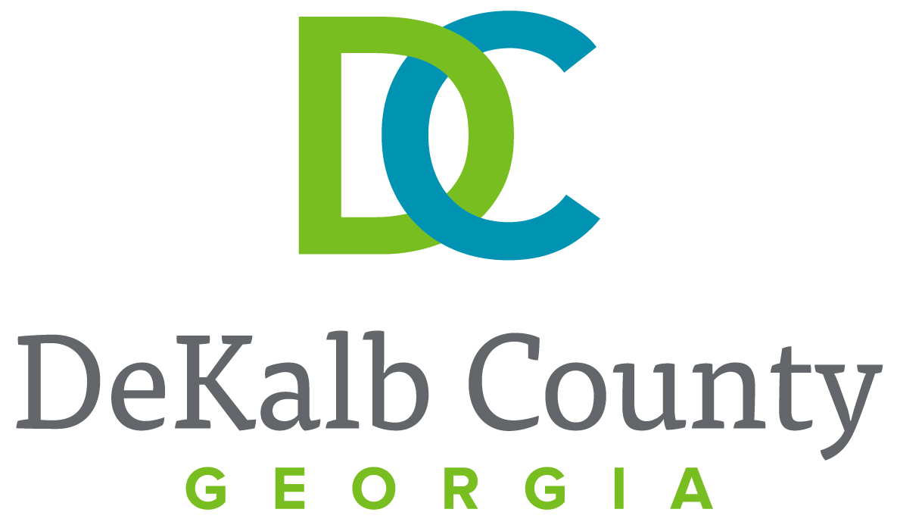

department of planning & sustainability

TREE OWNER’S GUIDE
An issue facing urban forests is the fact that trees die prematurely. Many are planted improperly, do not receive regular maintenance and are not adequately protected during construction projects.

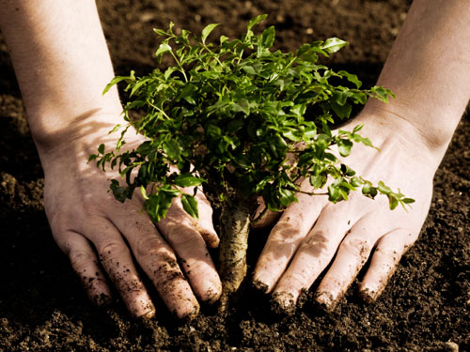
To help remedy this, the US Forest Service has created a Tree Owner’s Manual, posted at: http://na.fs.fed.us/urban/treeownersmanual/. In addition, the US Forest Service has a tree pruning manual: http://na.fs.fed.us/spfo/pubs/howtos/ht_prune/htprune-rev-2012-screen.pdf.
The Georgia Forestry Commission also has information for tree planting and care at:
http://www.gfc.state.ga.us/community-forests/ask-the-arborist/CommunityTreePlantingandEstablishmentGuidelinesPrintVersion.pdf
http://www.gfc.state.ga.us/resources/publications/Homeowner's%20Role%20in%20Maintaining%20the%20Urban%20Forest.pdf
These publications provide the homeowner with information on tree planting, care and maintenance.
TREE RISK ASSESSMENT
Property and tree owners assume a duty of care that must be undertaken to avoid negligence and liability. Being negligent in the care of your trees can lead to the eventual removal of the tree and legal actions if reasonable care is not undertaken by the property owner.
In order to avoid these issues it is important that the property owner practice reasonable care of trees, including having a professional risk assessment conducted by an International Society of Arboriculture (ISA) Certified Arborist. You can find a local arborist by going to the following websites:
- http://www.isa-arbor.com/findanarborist/arboristsearch.aspx
- http://georgiaarborist.org/page-62524
- http://www.gfc.state.ga.us/community-forests/management/professional-assistance/index.cfm
There are four compelling reasons to implement a Tree Risk Assessment and to have a structured program for tree inspections.
- Provide documented evidence that a property owner/occupier is compliant with their legal obligation to provide ‘due diligence’ and reasonable maintenance of their trees.
- Reduce the risk of harm to people and/or property by managing trees effectively. This involves a pro-active and systematic approach to identifying potential hazards, ranking them according to their severity and prioritizing actions to achieve an acceptable level of risk.
- Provide a prioritized and effective management schedule to aid in budgeting of maintenance and care.
- Ameliorate tree defects by prescribing remedial maintenance. This will extend the safe useful life expectancy of trees and preserve their important visual amenity including any wildlife habitats they may provide.
EXPLANATION OF TREE RISK ASSESSMENT
Trees are an important part of the urban landscape and are often taken for granted. Trees are important for visual amenity as their aesthetic beauty breaks up and softens the surrounding environment. Trees produce oxygen, filter pollution and shelter people and structures from wind and sunlight. Trees are living organisms and can be prone to failure of parts of their structure or, on rare occasion, total failure. Tree risks increase slightly in highly populated urban areas with a high concentration of people close to trees. Tree related accidents can be traumatic and fatal.
LEGAL FRAMEWORK
There is an obligation of reasonable care by a property owner or manager. The property owner/manager may be held liable for any physical harm to people or property arising from an accident that was reasonably foreseeable and reasonably preventable.
In order for a property owner/manager to foresee and prevent harm arising from tree failure, it is advisable that trees are regularly inspected by an ISA Certified Arborist who is competent to identify defects and interpret risk assessment. This should take the form of a formal ‘Tree Risk Assessment’ by an ISA Tree Risk Assessment Qualified Certified Arborist or someone who has the knowledge, experience and background to conduct a professional tree risk assessment.

DUTY OF CARE
- The law assumes that the property owner/manager of a tree is the property owner/manager of the land surrounding the base of its trunk.
- The person responsible for any tree has a duty, known in law as the duty of care or due diligence, to take reasonable care to avoid acts or omissions which they could foresee would be likely to cause harm.
- In practice it is not possible to completely eliminate all danger. The law therefore requires that the property owner/manager takes reasonable care to identify possible sources of foreseeable danger and remove them as necessary to minimize risk.
- Negligence is a breach of legal duty resulting in damage. For example, when a tree owner/manager fails to take necessary action, resulting in harm to people, animals or property.
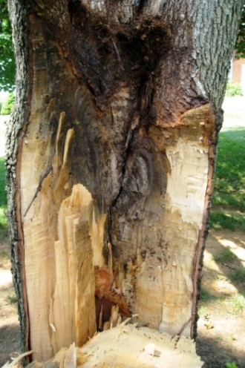
The law does not require or expect the impossible. The duty of property owners/manager is not to take every possible step to achieve perfect safety, as this would mean almost every tree being felled to remove all risk. The duty of the owner is rather to take all reasonable care to ensure that people are safe. What is "reasonable" must ultimately be a matter of judgment for the tree owner/manager and their professional advisers (tree consultants).
In order to provide an adequate duty of care, a tree risk assessment is necessary, in which the two separate factors of Hazard and Risk are addressed.
- Hazard is the potential for a tree to mechanically fail or impact a target and cause damage, physical harm or inconvenience.
- Risk is the likelihood that harm will occur during a stated period of time and the consequences of impact.
TREE RISK ASSESSMENT
Tree Risk Assessment is comprised of several factors which are considered separately. Risk is the likelihood of an identified tree hazard failing in the next year and impacting a target. The size of the identified hazard part of the tree is relevant. A small piece of dead wood may have the same risk of falling as a whole tree with basal decay but the consequences of failure are very different- ranging from slight injury or damage to possible fatalities or major structural damage. Target relates to the location of the tree and the occupancy and intensity of land use surrounding it. Any person, animal or property that is in range of a potential tree hazard is known as a target. For example, a mature tree with a large split limb in a remote woodland would be considered a high hazard but a low risk. The same tree on a busy urban street would be considered a high hazard and a high risk.
TREE HAZARDS
A tree’s shape and form is governed by the laws of mechanics, the same as any structure. However, trees are also dynamic and produce tension and compression wood to compensate for weight and wind or ice loading. Trees produce reaction wood in response to decay or structural weaknesses.
Trees are naturally shedding organisms and regularly drop leaves, twigs, branches and occasionally limbs as part of the natural growing process. A tree’s structural integrity can be compromised by natural faults and biological factors such as fungi, bacteria and viruses which influence wood strength at a cellular level. Trees can be impacted by environmental influences such as strong winds, icing, flooding, pollution, soil compaction, physical impact etc.
The signs of possible structural weakness are usually evident from external inspection by a trained and experienced arborist who can evaluate the potential hazardous risk and prescribe remedial action.
LIMITATIONS OF TREE RISK ASSESSMENT
- Tree risk assessment considers only known targets and visible or detectable tree conditions.
- Tree risk assessments represent the condition of the tree and site at the time of inspection.
- The time frame for risk categorization should not be considered a guarantee period for the risk assessment.
- Only those trees specified in the scope of work are assessed, and assessments are performed within the limitations specified by the property owner.
Trees are living organisms whose health and condition can change rapidly. The conclusions and recommendations in a Tree Risk Assessment report are typically valid for one year. Any changes to the site i.e. building extensions, excavation work, importing or stockpiling of soils, extreme weather events etc. will invalidate an assessment.
Any tree, whether it has visible weaknesses or not, will fail if the forces applied exceed the strength of the tree or its parts.
TIPS ON CHOOSING A TREE REMOVAL COMPANY
It is highly recommended that you choose a professional company for any pruning and removal work.
Companies that are accredited members of the Tree Care Industry Association have a very high standard of training and workmanship. Information can be found at their website:
http://tcia.org/TCIA/MEMBERSHIP/Find_Quality_Tree_Care/TCIA/Directories/FindQualifiedTreeCare.aspx?hkey=bef3d8df-3959-4996-a1dd-1a065e6be8c4
In contracting with a tree company, the lowest price may not offer the best quality work. The following recommendations should be considered when selecting a reputable tree company.
- Insurance: Make sure each tree service you are considering has appropriate liability insurance and workers compensation insurance. All certificates of insurance should be sent from the tree service’s insurance agency directly to you. Otherwise, it could be a fraudulent certificate. If a company has an accident, and does not have the proper insurance, then you may be liable. You could have to pay for repairs to your property and any injuries that may have occurred as a result of the accident.

- Better Business Bureau: Ensure that the company is accredited with the Better Business Bureau. Only a handful of tree services receive BBB accreditation and those that do are generally reputable. Also, find out what kind of rating the company has. The tree service should be in good standing with BBB.

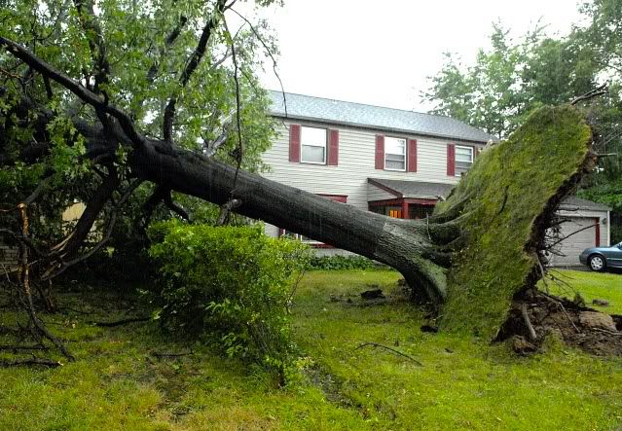
- Reputation: Do some research to find out what kind of reputation the tree service has with its local community. The right tree service should have positive online reviews in a variety of places. Check to see whether the company in question is a member of any reputable trade association, such as the Tree Care Industry Association, Georgia Arborist Association or International Society of Arboriculture. How long has the company been in business? Do they have any complaints on local forums, discussion groups, etc.? Ask the company for references, if you need the extra assurance. Especially for expensive projects, doing a bit of research is always worth the time.

- Too Cheap: If a price seems too good to be true, it probably is. If a tree service is giving you a very low price, it may be because they a) have no experience, b) do not have the proper insurances and certifications, or c) they only intend to complete part of the project.

- Too Expensive: Similarly, if a price seems too high, say no thanks.

- Multiple Estimates: How will you know if a price is too high or too low? It is recommended that you get estimates from at least three different companies. From the three estimates you should get some sense of what price is normal. If possible, it is recommended that you meet with each representative in person. This will give you a chance to judge the company’s expertise and professionalism. It will also enable you to ask questions, learn about more about what is involved, and so on.

- Compare Apples to Apples: When you consider different estimates, compare what is actually being offered. If one tree service is offering extra services or some extra benefit then you should take this into account. For example, perhaps one tree service plans on felling the tree whereas another tree service will remove it in small sections? Felling a tree is easier and requires less time, but it will cause more damage to your property. Piecing a tree down in small sections will cause minimal damage to your yard, but it requires more time and effort and thus it will generally be the more expensive option. This is also a good point at which to compare the service, professionalism, knowledge, presentation, etc. of each different company. Remember that price is not everything – you should listen to your instincts about which company is most trustworthy.

- Avoid Door-to-Door Contractors: Never do business with door-to-door contractors, particularly for large projects such as tree removal. The BBB and a number of district attorneys’ offices across the country regularly warn against this. Door to door contractors are often con artists that travel from town to town, preying on homeowners, particularly seniors. If you simply make it a policy not to do business with them, you will not have to worry about being caught in a scam. Besides, deciding to complete tree work on the spur of the moment is not a good idea – there are too many variables that must be carefully considered first.

- Use Caution After a Disaster: Natural and other disasters usually bring the con artists out in droves. Unfortunately, this may be the one instance where hiring a door-to-door contractor is necessary. If, for example, you have a tree lying on your house and there is no electricity, you may have to hire the first tree service that passes by. But even in this situation, make sure you are being charged a reasonable price. There are many examples of companies charging exorbitant rates for simple tree removal projects after a tornado, ice storm, etc. You should also ensure that the company has the necessary insurances and certifications.

- Pay When Satisfied: Once you have picked a tree service you feel comfortable with, the most important rule to follow is NEVER pay for a tree removal or tree trimming project of any kind until you are 100% satisfied with the work. There are countless instances of homeowners paying for a tree service project up front, only to never hear from the company again. The tree service industry is not like the building industry – there is no need to be paid in advance. One popular trick among disreputable tree services is to begin a project, collect money (for any number of reasons – “I have to pay my staff”, “we need money for fuel”, “we need payment to finish the job”, etc.), and then never return. This is especially true with stump removal. In this scenario the company has completely removed the tree and then asks for payment, promising to return later to remove the stump. Upon receiving payment, the company never returns. Remember: do not pay until the job is completely finished and you are happy with the service.

So long as you make contact with several companies, do your homework, make sure your company of choice is properly insured, get a written contract and exert common sense, you are more likely to choose the right tree service. Add to that never paying for a job until it is properly completed, and it is almost certain that you will avoid any sort of tree service scam altogether.

